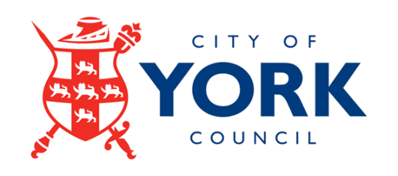

City of York Council

Independent Member Recruitment Information Pack

June 2021

Appointment of an Independent Audit and Governance Committee Member

Background Information

City of York Council is keen to implement continuous improvement in the areas of corporate governance and robust financial management. The Audit and Governance Committee provides an independent and high-level focus on the audit, assurance and reporting arrangements that underpin good governance and financial standards.

An independent review of arrangements in place to support the transparency and quality of local authority financial reporting and external audit was conducted and recommendations published in 2020. One such recommendation made concerned local authority audit committees to appoint at least one suitably qualified independent member.

Functions

The Independent Member plays a key role in scrutinising the authority’s statement of accounts for its approval. The Committee is also responsible for reviewing the Council’s corporate governance arrangements and overseeing the financial reporting process.

The successful applicant must be able to demonstrate the desire to serve the local community and uphold local democracy and be able to receive reports and presentations from key partners, including the Council’s internal auditors and external auditors.

The Committee provides independent assurance of the adequacy of the risk management framework and associated control environment and independent scrutiny of the authority’s financial and other performance to the extent that it reflects on exposure to risk or weakens the control environment.

To assist applicants, the following documents are attached:

- Independent Member Role Specification;
- Application Form.

Eligibility for Appointment

A person cannot be appointed as an Independent Member if they are or were within a period of five years prior to the appointment:

- A member, or co-opted member or officer of City of York Council,

- A member, or co-opted member or officer of a Town or Parish Council within the area of City of York Council,

or, if they have a relative or close friend of a person in (a) or (b) above – see below.

A relative is defined as:

- The applicant’s spouse or civil partner;
- Any person with whom the applicant is living as if they were spouse or civil partners;
- The applicant’s grandparent;
- Any person who is a lineal descendent of the applicant’s grandparent;
- A parent, brother, sister or child of anyone in paragraphs (a) or (b);
- The spouse or civil partner of anyone within paragraphs (c), (d) or (e); or
- Any person living with a person within paragraphs (c), (d) or (e) as if they were spouse or civil partner to that person.

There are also restrictions on appointment for persons who have been convicted of any criminal offence, or is an undischarged bankrupt and there are also requirements that the Member has not significant business dealings with the Council or any formal connection with any political group.

Financial management experience is an essential requirement for this role.

Information about the Role

The Independent Member will need to be contactable at all times during normal working hours by telephone or by email and will need to be available to attend Meetings which may be held in the day time or evening, sometimes at relatively short notice.

The Committee meets approximately five to seven times each year and the Independent Member will be required to attend these meetings.

This is not a job vacancy and should you be appointed as an Independent Member you will not be an employee of the Council. This role does not attract any financial recompense, other than reimbursement of necessary travel expenses.

The term of office will be for a fixed term for 12 months on appointment and will be subject to the Independent Member maintaining high standards of personal conduct. The Council may terminate an appointment at any time.

Completion and Submission of Application Form

The selection criteria for the role is set out in the role description. Please ensure that you carefully demonstrate in your application form how you meet the criteria, as this will be used to assist in the short-listing process.

Applications will be assessed by reference to your completed application form and, if shortlisted, by interview. Shortlisted applicants will be invited to attend for interview. The successful applicant will receive specific training to enable them to undertake the role effectively.

Applications must be received by midnight on Sunday 11 July 2021.

Interviews will be held during the week commencing Monday 26 July 2021.

