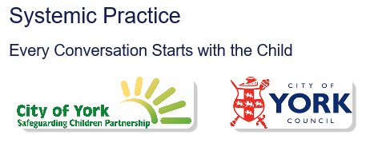

“We pledge to work in a way which acknowledges and supports the values of Systemic Practice, including a focus on the importance of relationships not just with the children and families we work with but also in relation to each other.”

“Our interactions with one another, and the children and families we work with will be consistent and includes partner agencies. We will consider wider systems and context and the importance of social GRACES. We will practice in a way which values and recognises the importance of these”.

“We will challenge ourselves to work in way which promotes curiosity and reflection in our practice with all partners and stakeholders to improve outcomes for children. We will be brave in our practice and whilst working in uncertainty at times, allow families to make changes and find their own solutions wherever possible.”

