Frequently Asked Questions

What is a dwellinghouse?
A dwellinghouse is a residential house or flat occupied by a single household such as a family. A dwellinghouse falls within Use Class ‘C3’ of the Town and Country Planning Use Classes Order which puts uses of land and buildings into various categories known as 'Use Classes'.

What is a House in Multiple Occupation
In broad terms a House in Multiple Occupation or HMO as they are commonly known is a house or flat occupied as their main residence by three or more unrelated people who share a communal kitchen, bathroom and/or toilet. In planning terms there are two different types of HMOs. Between three and six unrelated people sharing amenities is class as ‘C4’ or a small HMO. Large HMOs can be defined in broad terms of consisting of more than six unrelated occupants who share amenities and does not fall within any use class and are considered 'sui generis'.

What is an Article 4 Direction?
The Planning Acts allow for some types of development or changes of use to take place without planning permission – for example, small extensions to dwellings or changing the use of a building from a bank to a shop. These exceptions are set out in the “General Permitted Development Order”. An Article 4 Direction enables local planning authorities to remove a particular permitted development right in the interest of the proper planning of their area.

Why has the Council introduced this Article 4 Direction?
Whilst the Council accepts that HMOs play an important role in providing low cost housing, particularly for young people, it wishes to ensure that HMOs are more evenly dispersed throughout the city. The Article 4 Direction removes permitted development rights, requiring a planning application to be submitted to change a property into an HMO. This applies to the main urban area as shown within the red line boundary on the following map and came into effect from 20 April 2012.

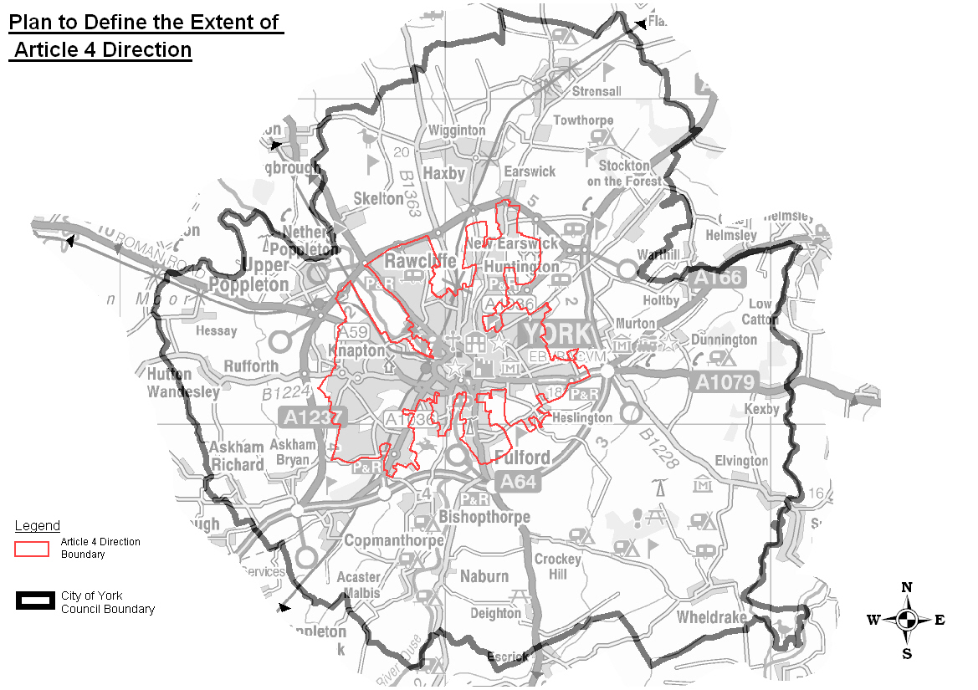

How will planning applications for HMOs be decided?
Decisions will be based on the approved Supplementary Planning Document (SPD) and other material considerations. As set out in the SPD, a threshold based policy approach is considered most appropriate which identifies a ‘tipping point’ when issues arising from concentrations of HMOs become harder to manage and a community or locality can be said to tip from balanced to unbalanced. Under the threshold approach an assessment of the proportion of households that are HMOs is undertaken within a given area. Whilst there is no formal definition of what constitutes a balanced community, recently, for York, through consultation, a threshold of 10% of all properties being HMOs within 100m and 20% across a neighbourhood area have been established as the point at which a community can tip from balanced to unbalanced.

How long will it take for my planning application to be dealt with by the Council’s Planning Department?
As a guideline there is a national target for local authorities to decide 80% of planning applications within 8 weeks of the application being validated by the Council.

What planning application form should I use?
In the case of applications solely affecting a material change of use to an HMO a full planning application form should be submitted. The Council would request that further details of how the building will be used (including the number of existing and proposed bedrooms, likely and existing occupancy and the location of ancillary refuse and cycle storage) should be provided. If you are seeking to extend and change the use of property to create a new HMO, or are seeking to extend an existing HMO than a householder planning application form should be submitted.

What is the fee for an application for change of use to HMO (without extension)?
From 17th January 2018, the Council has implemented a revised national charging scale for planning applications. A fee is also now payable for applications which follow the removal of permitted development rights through Article 4 directions or by condition. For a change of use from C3 dwellinghouses to C4 HMO’s, a fee of £462 will now be payable for such applications.

What is the fee for an application for change of use to HMO (where it includes an extension)?
From 17th January 2018, where this change of use to a HMO also include an extension to the property, the same fee (£462) would be payable.

I own a house which I have let to a group of between 3 and 6 non-related people in the past but this year it has been vacant as I have been unable to find tenants. Will I need planning permission to move new tenants in?
No. If the house was last used as a Use Class C4 HMO on or before 20 April 2012 then you do not need permission to re-let the property after it has been vacant for a short time. Similarly you would not need to reapply for planning permission every time a C4 HMO property is re-let with new tenants.

I own a house which I live in with my family but we want to take in one or two lodgers. They would have their own bedrooms but share the kitchen with us. Would I need planning permission to do this? I’m not intending to do any building work.
Government guidance states that properties containing the owner and up to two lodgers do not constitute an HMO. As such planning permission is not required where the property owner and their household live with up to two lodgers. The owner means the person who has the freehold estate or a leasehold. Co-habiting couples are considered to be family. An owner occupier, their household and three or more lodgers will be an HMO.

I own a house which I have let to a group of between 3 and 6 non-related people in the past but this year I struggled to find tenants so I have let it to a family for 6 months – will I need planning permission to let it as a C4 HMO again?
Yes. You will need to apply for planning permission if the house has been used as a C3 dwellinghouse since 20 April 2012. Similarly, if a property was let as an HMO on the 20 April 2012, but has since been let to a single family or is let to a single family in the future it would also need planning permission to become an HMO again. Renting to fewer than three unrelated individuals would also mean the use of the property has changed from an HMO to a C3 dwellinghouse.

What do you recommend I do if I’m looking for flexibility to let the property to both family groups and shared tenants?
It is recommended that a flexible C3/C4 permission is sought. This would require a planning application to be submitted, but would allow continuous occupation of the building as either a dwellinghouse for a family or an HMO for unrelated tenants for a period of 10 years without the need for subsequent planning applications. If the property is currently occupied as an HMO, and greater flexibility is required, a planning permission would be required before the building can be used flexibly for C3/C4 uses.

What planning application form should I use for a flexible permission?
A full planning application form should be submitted with details of how the building will be used (including the number of existing and proposed bedrooms, likely and existing occupancy and the location of ancillary refuse and cycle storage). From 17th January 2018, the fee for a flexible change of use application is £462.

Would a house which was occupied by between 3 and 6 unrelated people prior to 20 April 2012 require Planning Permission?
It only applies to changes of use which take place on or after 20 April 2012. If the C4 use was established prior to 20 April 2012 then this will be considered its lawful use. However a property must have been in use continuously as a C4 HMO since 20 April 2012. Larger unauthorised “Sui Generis” HMOs would still require retrospective permission and may be the subject of an enforcement investigation to remedy any harmful breach of planning control.

What can I do if I want to confirm an existing HMO?
A landlord may apply to the Council for a ‘Certificate of Lawfulness’ to formally confirm the existing lawful use of a property as an HMO in cases where it is not an established HMO under the Council’s planning records. A certificate can be applied to confirm the lawful use of a large or small HMO. A small C4 HMO occupied on or before 20th April 2012 will be deemed the lawful use after this date. Satisfactory evidence will be required to demonstrate the lawful occupation of the HMO since 20th April 2012. If a Landlord does not want to regularise their HMO, it is strongly recommended that they retain sufficient documentation to demonstrate lawful use as a small HMO since 20th April 2012, or 10 years as a large HMO. This will reduce the owner’s risk of the Council taking enforcement action against them.

What type of evidence do I need to include with an application for a Lawful Development Certificate?
To demonstrate that a property has been an established HMO since 20 April 2012 you must submit evidence relating to the use of the property. The onus is on the applicant to demonstrate to the local authority that a certificate should be issued. Applications are determined on the basis of the evidence submitted. Therefore, the evidence submitted should be clear and convincing. This evidence may include signed tenancy agreements, details of rents provided, details from the electoral role and/or Council Tax records and appropriate utility bills.

What planning application form should I use for a Lawful Development Certificate and what is the fee?
A Lawful Development Certificate for an existing use application form should be submitted. The fee for submitting an application for a lawful development certificate is £462 for establishing a C4 small HMO or large HMO.

Do I need planning permission to add additional rooms to an authorised C4 HMO?
If additional rooms can be accommodated without external development works, planning permission would only be required if the completed building is to be occupied by more than 6 unrelated people as a change of use to a large HMO may have occurred.

Do small C4 HMOs and large ‘sui generis’ HMOs have permitted development rights?
Following advice from the Planning Inspectorate small and large HMOs can normally benefit from permitted development rights. However there maybe some cases, for example bed sit type large HMOs, where not all HMOs would necessarily have permitted development rights. It is recommended that an application for a Lawful Development Certificate for proposed development is submitted or pre-application advice from the Council is sought. For further information please on the pre-application service provided by the Council please contact planning enquires on 01904 551550 or at planning.enquiries@york.gov.uk

