City of York Council

Accessible Seating Review and Inclusive Design Framework

# Contents

### Project Background 2

1. Our Approach 3

2. Scope of Audit 3

3. Criteria for Assessment 4

4. Legislative Context 4

### Accessibility Audit

A1 – Outside the Grand Hotel 6

A2 – Bus stops in Museum Street 7

A3 – Outside Explore Library 10

A4 – St Helens Square 11

A5 – Black benches across the city 13

A5 – Temporary seating in Parliament Street 15

### Inclusive Design Framework

6. Overview 16

7. Seating locations 16

8. Seating Heights 17

9. Seating Features 17

10. Picnic Benches 19

11. Seating relating to transport 19

12. Accessibility standards and guidance 20

12. Seating design, construction and maintenance 20

14. Wider accessibility provision 20

15. ‘Happy to Chat’ bench 21

**16. Survey 21**

Decision 23

# Project Background

As part of City of York Council’s programme to create ‘an accessible and inclusive York for all’, the council has identified a number of activities in the ‘Access to the Footstreets Project’, in order to improve the accessibility of York city centre.

The council has mobilised a workstream dedicated to improving the seating and resting facilities across York, in order to address both the lack of benches and seating/resting facilities in the city centre, and the design barriers of existing benches for those with accessibility requirements.

This workstream was highlighted as a result of the recent decision by City of York Council to remove blue badge access to the pedestrianised streets.

For this workstream, Accessibility and Inclusive Design Consultants from Mima were tasked to undertake:

* A site-visit to understand the seating infrastructure and locations of public seating across the city centre.
* An accessibility assessment to identify current barriers for users with physical, sensory, cognitive, temporary and situational impairments and access requirements.
* A review of the current seating against best practice guidance and design standards to identify opportunities for improvement, and the creation of an inclusive design framework for seating and dwell areas.
* Consultation with disabled users on the current seating designs in the city centre, in order to inform Mima’s final recommendations to the council.

### This document has been produced in two sections:

1. An **Accessibility Audit**, providing insights into the current seating provision, and recommendations for improvement. Access audits are a brief ‘snapshot’ of an existing venue or product at a particular point in time and present a current assessment view (AS-IS) against the recommended future state (TO-BE) for accessibility.
2. An **Inclusive Design Framework**, outlining best practice design requirements for accessible seating, supported by content in leading technical standards. Also included in this framework are actions City of York Council can take to ensure public awareness of, and engagement in, inclusively designed seating provision across the city.

## Our Approach

Our approach is based on inclusive design principles which aim to improve usability and accessibility for all, regardless of human characteristics such as age, gender identity, size, height, ability etc. For this project, our approach has an enhanced focus on disability including physical, sensory and cognitive impairments in the design of seating in the public realm.

### The following key terms are explained below:

Accessibility is the practice of making information, activities, and/or environments meaningful and usable for as many people as possible. It acknowledges a wide range of physical, sensory, and cognitive human capabilities and characteristics we need to consider when we design our buildings, places and products from a usability perspective.

**Inclusive Design** is a “process that ensures all buildings, places and spaces can be easily and comfortably accessed and used by everyone.”(UK Government)

**An Inclusive Environment** “recognises and accommodates differences in the way people use the built and natural environment. It facilitates dignified, equal and intuitive use by everyone. It does not physically or socially separate, discriminate, or isolate. It readily accommodates and welcomes diverse user needs” (Construction Industry Council).

**Disability** ‘Under the Equality Act 2010, a person identifies as disabled if they have a physical or mental impairment which has a substantial and long-term adverse effect on their ability to carry out normal day-to-day activities. This can include physical, sensory, neurodevelopmental, cognitive, mobility and health conditions.’ (Equality Act, 2010)City of York Council - Seating Accessibility Audit.

## Scope of Audit

This audit is an assessment of the accessibility and usability of seating in York city centre for people with physical, sensory and cognitive impairments, against best practice inclusive design requirements. However, it should be noted that the recommendations within this report would positively impact the convenience of access to and use of the seating for all occupants, not just those with accessibility requirements as mentioned above.

### In scope

This audit included an assessment of mixed use seating of varying types across the city centre of York, including:

* Permanent seating and benches
* Temporary seating installations Out of scope

This audit **did not** include an assessment of the surrounding public realm, including:

* Footpaths, wayfinding, Signage, other street furniture

## Criteria for Assessment

The criteria for assessment is the need to maximise access to and use of the seating from a user perspective, including practical considerations of accessibility improvements. Our assessment has been undertaken against the following accessibility and inclusive design standards, including:

* **Approved Document M:** ‘Access to and use of buildings’, volume 2: Buildings other than dwellings. 2015 edition, incorporating 2020 amendments.
* **BS 8300: 2018 ‘Design of an Accessible and Inclusive Built Environment’,** Part 1: External environment
* **PAS 6463:2022 ‘Design for the Mind -** Neurodiversity and the Built Environment’ This assessment has been informed by additional guidance including:
* **Department for Transport, ‘Inclusive Mobility:** A Guide to Best Practice on Access to Pedestrian and Transport Infrastructure’, 2022
* **National Disability Strategy, 2021**
* **Historic England, ‘Easy Access to Historic Landscapes’, 2015**
* **Guidance on the Provision of the Equality Act, 2010**

## Legislative Context

In the UK, the Equality Act (2010) places a duty on both public and private service providers to ensure people with certain protected characteristics are not discriminated against. This duty is to:

* eliminate unlawful discrimination
* advance equality of opportunity
* foster good relations.

Disability is one of the specified protected characteristics. Protection from discrimination applies to disabled people in a range of circumstances, covering the provision of goods, facilities and services, the exercise of public functions, premises, work, education, and associations.

It is now widely accepted that disability happens at the points of interaction between a person and society known as the social model of disability, compared to the medical (historical) view which deems disability to be a personal attribute that needs to be ‘cured’ or ‘fixed’.

While the Equality Act does not directly require accessible environments to be provided for disabled people, it does state that service providers have a legal duty to make reasonable adjustments that remove barriers to access.

The Equality Act does not require a service provider to meet obligations in a particular way, but rather suggests removing, altering or providing a means to avoid any potential barriers, or providing reasonable alternative methods of making a service, product or building available to disabled people.

## Accessibility Audit

Whilst York provides many attractions and forms of entertainment for residents and tourists alike, it was noted during Mima’s site visit on Tuesday 6th December 2022 that relatively few opportunities for seating, shelter and general dwell space are provided across the city centre. The below table showcases some of the seating types available and provides recommendations to improve accessibility. References to relevant guidance documents are also provided.

|  |  |  |  |  |
| --- | --- | --- | --- | --- |
| Ref. | Seating Type | Current Situation | Recommendations to Improve accessibility | Guidance Reference |
| A.1 | Outside the Grand Hotel | The bench is easily identifiable, with a black seating frame and armrests contrasting against the light brown body of the seat. This against the pale grey paving stones, makes it easily identifiable providing good visual and tonal colour contrast.  The bench is 480mm in height; the backrest meets relevant guidance as it is over 300mm in height.  There is ample space underneath the bench for assistance dogs to rest away from crowds, should this be required.  Armrests have been provided on the bench aiding good mobility support. There is also ample space provided should users wish to be seated away from the armrests and place their belongings next to them. Whilst at least 1200mm clear width of transfer space is provided at each end of the bench, wheelchair users requiring a lateral transfer are unlikely to be able to transfer safely due to the armrests present at both ends of the bench.  The central armrest extends from the back support forwards to cover at least 80% of the depth of the seat in line with recommended best practice.  The armrest currently does not meet other best practice guidance requirements, as it is at a height of under the recommended 200mm.  The armrests provided on the bench are encased in plastic, providing a differing texture that is warm to touch. This aids identification and ease of use. | Recommended Actions:   * Adjust armrest to correct height of 200mm. * Remove armrest from one end of the bench, providing lateral transfer opportunity for wheelchair users. * Where possible and whilst promoting safety, provide aesthetically pleasing shelter around several of these benches that are present in a few city centre areas.   Requirements as recommended in DfT’s Inclusive Mobility, 2022:   * Armrests when provided help people lower themselves onto the seat and stand up. These should provide at a height of 200mm from the surface of the seat. | DfT Inclusive Mobility, 2022  Section 11.5  BS 8300-1:  2018  Section 10.7 |

|  |  |  |  |  |
| --- | --- | --- | --- | --- |
| A.2 | Bus stops in Museum Street | Currently there are three sets of benches provided under a shelter next to one of York’s bus stops, providing ample dwell space for passengers waiting for a bus, or those pausing for a break before continuing their journey. The seating area is placed outside of access routes with heavy pedestrian flow and provides a quieter rest area with considered sightlines.  The bench seating is made of dark brown wood. The seating armrests are black and encased in plastic. Both of these materials are warm to the touch.  However, the black armrests do not contrast appropriately against the seating surface, making them difficult to identify and utilise.  The armrests extend from the back support forwards to cover at least 80% of the depth of the seat, in line with recommended best practice.  The dark brown benching contrasts well against the lighter stone wall it is encased in, and the grey paving on the ground. This provides good visual colour contrast against the surroundings.  The bench seating provided is on a slope and therefore the seats are at a variety of heights. Whilst this is positive in the sense that much of the seating aligns with BS8300-1:2018 guidance of seating being provided at heights of 380-580mm, sloped access could cause difficulty for some users.  Whilst there is adequate space for wheelchair users to be integrated within the general seating provision provided at the bus stop, a lateral transfer space is not available. | Recommended Actions:   * Ensure a lateral transfer space of at least 1200mm clear width is provided for wheelchair users. * Provide variations of accessible seating, this could include:   + An inclusively designed seat at a height of 580mm.   + Perch seats at a height of 700mm.   Requirements as recommended in DfT’s Inclusive Mobility, 2022:   * - The provision of seating for passengers is important because older and disabled people have varying needs, therefore it is important that different styles of seating with a range of heights are provided. * Shelters provided at transport hub waiting areas should incorporate a bench, a platform or horizontal rails that passengers can rest against, at a height of about 580mm.   Perch-type seating enables people to half lean and half sit, and this type of seating is recommended to be at a height of 700mm.  Requirements as recommended in BS8300-1:2018:   * Where more than one seat is installed in a pedestrian area, a variety of seat heights should be provided; including at least one each with a seat height of 380 mm, 480 mm and 580 mm from ground level. * To enable a wheelchair user to transfer laterally onto a bench seat, a level transfer space 1 200 mm wide should be located at one end, with an arm rest set in 500 mm to 750 mm from the transfer space. Where there is more than one bench seat, a choice of left and right transfer should be provided. | DfT Inclusive Mobility, 2022  Sections 9.4  and 11.5  BS 8300-1:  2018  Section 10.7  PAS 6463:  2022  Section 7.7 |

|  |  |  |  |  |
| --- | --- | --- | --- | --- |
| **A.3** | Seating outside York Explore Library | There are three long platforms provided outside York Library, with seat heights of 710mm. This is far too high for comfortable use (aside from temporary perching).  Whilst 1200mm lateral transfer space for wheelchair users is available at certain sides of the platforms, the platform height removes this as a safe possibility.  The positioning of the platforms is pleasant, with quieter dwell space and pleasing sightlines available for those looking to remove themselves from primary access routes and thoroughfares.  However, there are no supportive back or armrests provided on these platforms, resulting in difficult use for many residents and visitors with mobility impairments and additional requirements, in particular.  There is poor colour contrast between the top of the platform surface and its surrounding grey floor. | * To enable a wheelchair user to transfer laterally onto a bench seat, a level transfer space 1 200 mm wide should be located at one end, with an arm rest set in 500 mm to 750 mm from the transfer space. Where there is more than one bench seat, a choice of left and right transfer should be provided.   Requirements as recommended in DfT’s Inclusive Mobility, 2022:  Seating should be tonally and colour contrasted with its surroundings for ease of identification. | DfT Inclusive Mobility, 2022  Section 11.5  BS 8300-1:  2018  Section 10.7  PAS 6463:  2022  Section 7.7 |

|  |  |  |  |  |  |  |
| --- | --- | --- | --- | --- | --- | --- |
| A.4 | | St Helens Square | At St Helen’s Square, seating was also present surrounding a central black pillar, and at a height of 440mm. Whilst the mid-brown wooden seat contrasts relatively well with the black pillar and lighter grey paving stones, there are no armrests provided and the pillar is the only element that would be able to be utilised as a backrest.  Furthermore, contrasting armrests would improve the inclusivity and useability of this seating, and enable lateral transfer for wheelchair users. | Recommended Actions:   * Ensure seats in isolation are between 450-480mm in height. * Provide armrests at 200mm in height, and backrests at least 300mm in height. * Provide adequate tonal and colour contrast to improve visibility.   Requirements as recommended in BS 8300-1: 2018:   * Arm rests should be provided to help people lower themselves onto the seat and stand up. These should be provided at a height of 200 mm from the surface of the seat and should extend from the back support forwards to cover at least 80% of the depth of the seat. Arm rests should contrast visually with the remainder of the seat to ensure that they are easily identifiable. There should be a space between arm rests of at least 500 mm.   Requirements as recommended in DfT’s Inclusive Mobility, 2022:   * Seating should be tonally and colour contrasted with its surroundings for ease of identification. | DfT Inclusive Mobility, 2022  Sections 9.4  and 11.5  BS 8300-1:  2018  Section 10.7 | |
| A.5 | Across the City | Several black benches were identified on our site visit. They contrasted well against lighter grey paving stones, providing good visual and tonal contrast.  The benches are 440mm in height with a high 550mm backrest. 1200mm space for lateral transfer was also available in selected areas. However, no armrests were provided on the benches. | Recommended Actions:   * Ensure seats in isolation are between 450-480mm in height. * Provide armrests at an accessible height of 200mm, and ensure they cover at least 80% of the depth of the seat. * Where possible and promoting safety, provide aesthetically pleasing shelter around several of these benches that are present in a few city centre areas.   Requirements as recommended in DfT’s Inclusive Mobility, 2022:   * Armrests when provided help people lower themselves onto the seat and stand up. These should be provided at a height of 200mm from the surface of the seat.   Requirements as recommended in BS 8300-1: 2018:   * Arm rests should be provided to help people lower themselves onto the seat and stand up. These should be provided at a height of 200 mm from the surface of the seat and should extend from the back support forwards to cover at least 80% of the depth of the seat. Arm rests should contrast visually with the remainder of the seat to ensure that they are easily identifiable. There should be a space between arm rests of at least 500 mm. | | DfT Inclusive Mobility, 2022  Section 11.5  BS 8300-1:  2018  Section 10.7 |

|  |  |  |  |  |
| --- | --- | --- | --- | --- |
| A.6 | Temporary Benches | In the city centre, we noted a number of temporary bench seating installations that have been provided by event suppliers. Here in St Sampson’s Square is a temporary bench provided as part of the Christmas Market.  The bench provided here in light brown wood is not easily identifiable against tonally similar light grey paving stones. The height of the bench is 500mm, no armrests are provided and the seat advertisement acts as a secondary backrest - this is neither appropriate nor safe in terms of best practice inclusive design.  Due to the placement of the seat, its temporary design and strength, and general busyness of the area, it is unlikely wheelchair users would be able to utilise it for lateral transfer. | Recommended Actions:   * Avoid the installation of temporary seating, wherever possible. * Prioritise comfortable and safe dwell space over advertisement. * Ensure any newly installed seating follows the inclusive design framework (below). |  |

# Inclusive Design Framework

## Overview

Generally, seating areas should be designed to promote a welcoming dwell space to all users, regardless of accessibility requirements or other needs. Outlined below are the inclusive design features that seating in the city centre should possess to ensure ease of identification, access and use by York residents and visitors.

## Seating Locations

A seating or dwell space opportunity should be provided at a maximum of every 50 metres across York city centre. Seating provision should also be increased in other areas of the city where dwell space is more likely to be required (for example, in shopping areas or by community venues).

Where possible and practicable, all seating provision across the city should be permanent and not temporary or a ‘moveable feast’. Not only is temporary seating often less structurally sound, but residents and visitors with accessibility requirements are likely to plan their routes around available dwell spaces, and the presence or disappearance of temporary seating is known to cause navigational difficulty for blind and partially sighted individuals, in particular.

Whilst it is noted that advertising can help to fund the cost of seating in some cases, the primary purpose of all seating must be to provide a safe and comfortable dwell opportunity for all users, and not to advertise.

Seating should be placed on a hard, level surface, not on a raised kerb or platform, grass, or on a sloped gradient.

Wherever possible and practicable, seating should not be placed in, or extend into, access routes in which the clear width would be narrowed to less than 2000mm. This width allows wheelchair users - and those with larger powerchairs or mobility scooters - to pass one another comfortably. The presence of surrounding street furniture should also be considered when finding a suitable location for seating, so as not to create too much ‘street clutter’ or navigational obstacles for residents and visitors.

Where relevant, views and sense of place should be taken into account when considering where to place a seat or cluster of seats, as should the ability for the seat to provide shelter from the elements. If not under cover, seating should be designed so that rainwater does not collect on it.

Lighting provided around seating should be designed to maintain a level of illumination that is comfortable and provides a safe environment. It should aid navigation for blind or partially sighted users, and communication for D/deaf or hard of hearing people who sign or lip read.

Seating placed in quieter locations may benefit those who experience sensory overload and this should be considered, where possible. However, to mitigate risk and encourage safety and security at all times, appropriate lighting and sight lines surrounding quieter seating or dwell spaces must be ensured.

Where possible and practicable, welcoming and useful ‘dwell space’ should be created within larger, city centre seating areas. Visual and tactile orientation maps, for example, should be available nearby, and the placement of seating near green spaces and shrubbery should be considered in order to create areas of calm within an often busy York.

## Seating Heights

At least half of all seating, and all seats provided in isolation, should be between 450mm and 480mm in height. At least one higher and lower seat (at 380mm and 580mm from floor level, respectively) should also be available within seating clusters to benefit children, those of shorter stature and older users.

## Seating Features

Where clusters of seats are provided - and across the city centre as a whole - there should be consistency in the visual design of seating whilst offering height and feature variation. This aids identification for blind and partially sighted users, whilst providing autonomy of choice and use to all. Backrests should be provided on all seats across the city centre, wherever possible and practicable. These backrests should be at least 300mm in height.

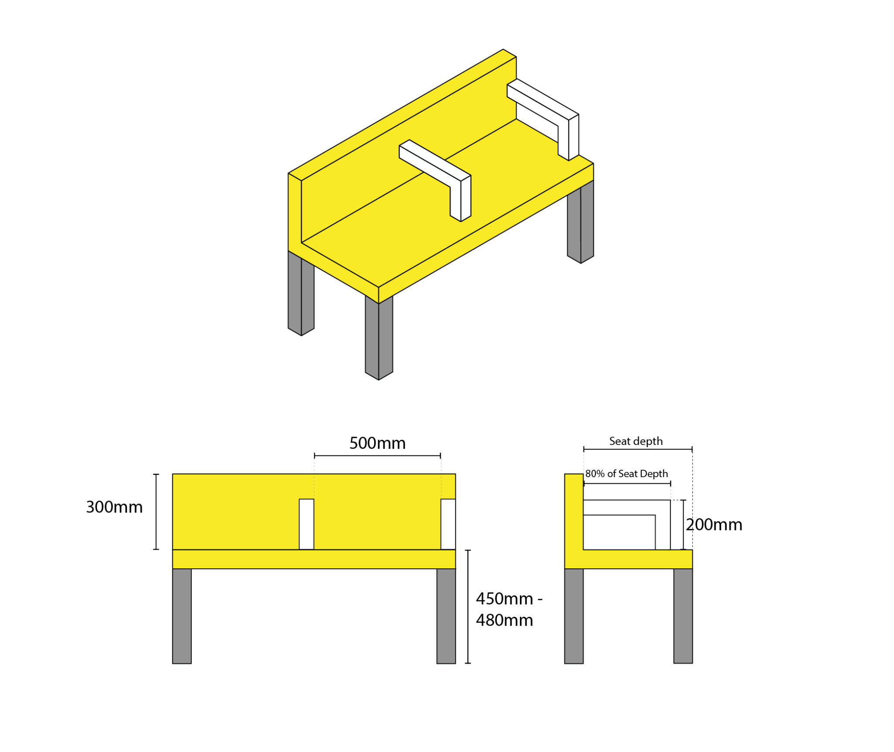

At least half of all seating, and all seats in isolation, should provide armrests. This also includes central armrests on longer benches. Armrests should be set at 200mm from the seat surface and extend to cover at least 80% of the seat’s depth. Armrests should be a minimum of 500mm apart from one another.

In seating clusters, armrests should be installed on a variety of seat heights to ensure all users are able to access the support they require.

To aid identification, ease of access and use, all seating should solidly contrast against the surface it is placed on, and its wider background. Where possible and practicable, seating legs should contrast with the pavement, and armrests should contrast with the seat, by at least 30 points in Light Reflectance Value (LRV).

Seating should not have a highly reflective finish, and patterns that are likely to cause visual confusion, disturbance or overwhelm should not be used.

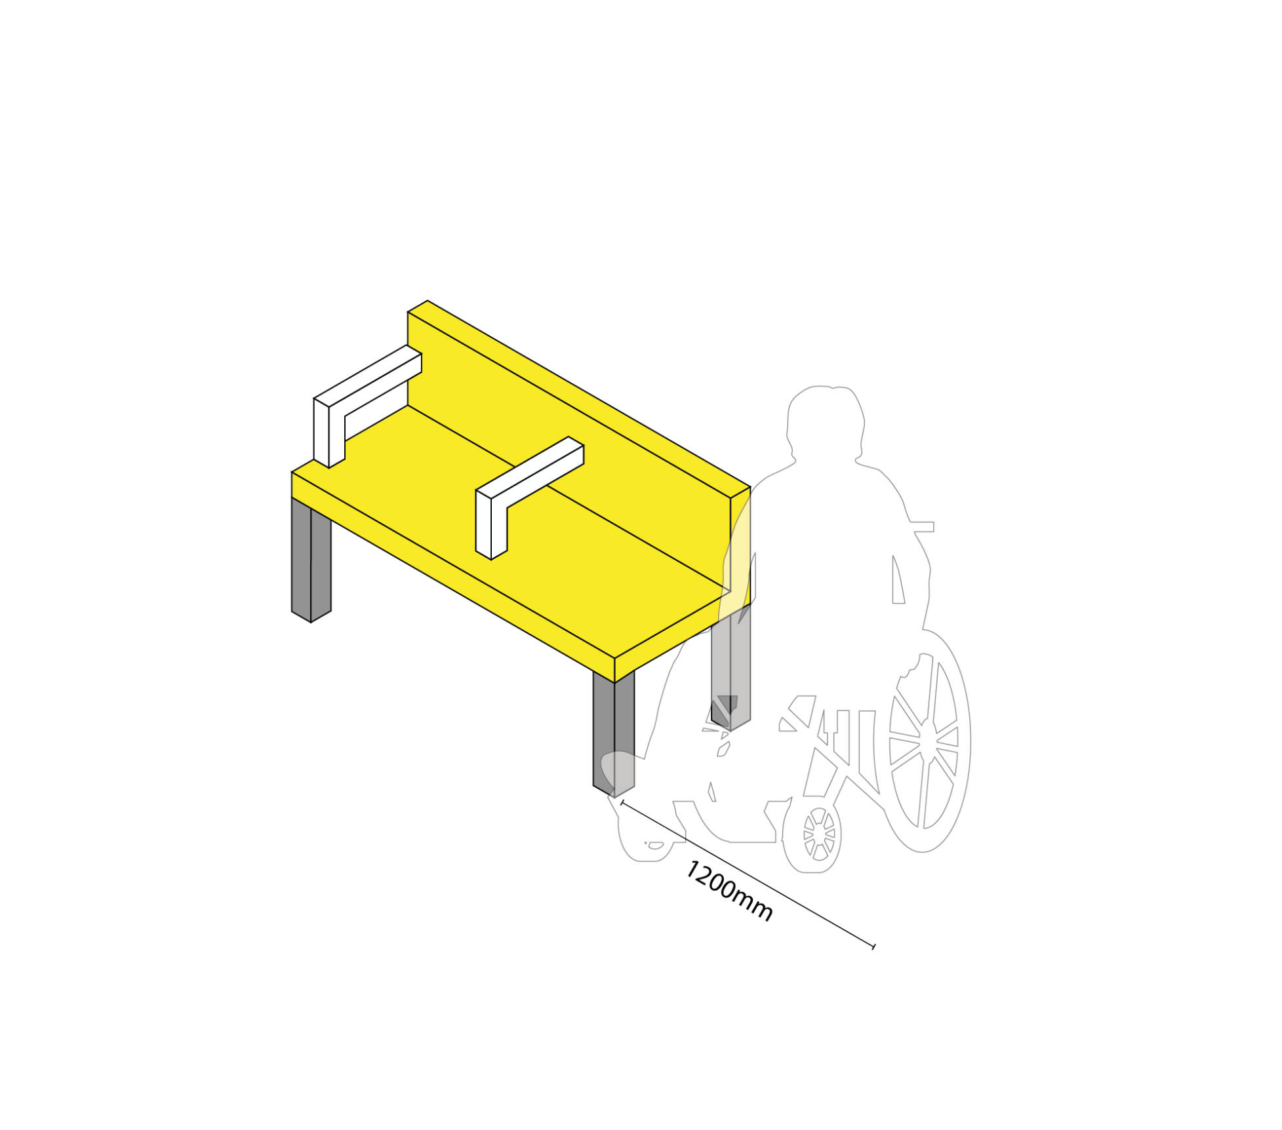At least half of all seating, and all seats in isolation, should be positioned so that they provide at least 1200mm clear width in lateral transfer space for wheelchair users. A mixture of right and left hand transfer should be offered and both should be available, where possible and practicable. These spaces will also provide dwell opportunity for assistance dogs and allow visitors to place luggage and mobility aids away from access routes.

They should not be narrowed or removed by additional street furniture. To enable lateral transfer, an armrest should be set 500mm to 750mm into the seat and from the transfer space.

The consideration of comfortable material use is also important in the inclusive design of seating across York city centre. Materials that do not conduct heat or cold - such as wood or recycled plastic - would be advised, to prevent an uncomfortable or painful experience for users.

## Picnic Benches

All picnic benches installed within the city centre should follow all relevant guidance above, particularly in relation to seating height, materiality and colour contrast. It is recommended that with every installation of up to five picnic benches, at least one wheelchair accessible picnic bench is provided, and for installations of six picnic benches or more, a minimum of two wheelchair accessible picnic benches are provided.

Wheelchair accessible picnic benches are often designed in one of two ways:

* By lengthening the central table at one end, providing an appropriate knee recess for wheelchair users and allowing comfortable, non-conflicting dwell space for both the wheelchair user and those seated on the surrounding benches.
* By shortening one bench, providing both a dwell space and lateral transfer opportunity for a wheelchair user that promotes ease of table use and seating next to companions.

A minimum of 1500mm clear width should be available between any wheelchair accessible picnic bench and nearby furniture to allow wheelchair users to utilise the space and turn effectively.

## Seating related to Transport

Seating should be provided at all transport stops (including the stops finalised for the proposed city centre bus shuttle service) and should follow all relevant guidance noted above. Higher seat heights of approximately 580mm are often provided at bus stops to encourage ease of seating and standing, and wheelchair users are less likely to transfer onto seating in the

time-pressured environment of transport. However, 1200mm clear width should still be provided next to seating rows to promote dwell space next to companions.

As rows of seating are likely to be installed in bus stops and similar, consistency of design is important. All seats should therefore have a minimum width of 500mm, provide backrests at least 300mm in height from the surface of the seat, and provide armrests. Where possible and practicable, fold down seats should not be installed. Perch seating should only be installed in addition to more widely accessible seating, and the suggested height for this is 700mm.

## Accessibility Standards and Guidance

All seating across the city centre should be designed to align with best practice accessibility standards, including:

* **BS 8300: 2018, ‘Design of an Accessible and Inclusive Built Environment’, Part 1:** External environment
* **PAS 6463:2022 ‘Design for the Mind** - Neurodiversity and the built environment’
* **Department for Transport, ‘Inclusive Mobility: making transport accessible for passengers and pedestrians’**, 2022
* **Historic England, ‘Easy Access to Historic Landscapes’**, 2015

At the beginning of every project where seating in the public realm is to be provided, or upgraded, an accessibility audit or design appraisal should be conducted by the Council against the above Inclusive Design Framework and best practice technical design guidance. This will ensure that any accessibility barriers are highlighted and opportunities for improvement identified.

## Seating Design, Construction and Maintenance

Whilst the inclusive design of seating is incredibly important, so too is the correct installation of the seating. Therefore, design and construction teams should work closely together to ensure all accessibility requirements related to seat installation have been understood. Placing a seat in a way that disrupts the use of tactile paving, removes transfer space for a wheelchair user or inappropriately narrows an access route, for example, can cause an otherwise inclusive design to have detrimental practical use.

Attractiveness and aesthetics are also an important part of seating considerations. Seats and their surrounding areas should remain sensorily appealing with appropriate cleaning and maintenance measures.

## Wider Accessibility Provision

The correct, inclusive design of seating and dwell spaces across the city centre is vital, as is ensuring residents and visitors are aware of the seating locations and facilities that would most benefit them.

It is strongly recommended that information on seating location and design is provided to the public via the council website, and that this is updated quarterly. This will grant residents and visitors the autonomy to plan their journeys in line with the type of seating or dwell space they require at certain points.

In line with this, it is recommended that the Council recruit and regularly meet with a pan-disability accessibility panel for all seating design reviews and new installations, and that a feedback platform is established to enable open discourse with the public on inclusive design within the public realm.

The ability to test seating prototypes prior to purchase and installation would be strongly advised and was a desired activity raised by those with lived experience of disability in Mima’s accessibility workshop on seating provision.

The provision of priority seating signage was also discussed, with the majority of user group members stating that they would not be supportive of this as they were uncertain of whether it would be followed in the public realm and therefore add benefit to the experiences of disabled people and those with additional requirements.

An accessibility statement should be available on the council’s website to share the Council’s commitment to accessibility and the high-level strategic approach it will take - relating to standards/guidance compliance, user consultation, and/or project ownership - to rectify identified issues in the short, medium and longer term.

## Happy to chat Bench (see bench 2 below)

* Everyone spoken to like the idea of a Happy to Chat bench.
* People agreed that the current location was too close to the main road for people who had a hearing impairment.
* A bench in the middle of the Front Street was a preferred location, on the right-hand side as it is warmer when the sun is out.

## Our new accessible bench

In January 2023, two bench designs were identified that closely met the criteria highlighted in this report, we could not identify an ‘off the shelf’ exact match.

The new bench is in addition to any existing benches and not to replace them unless they are beyond repair.

Both benches were installed outside the Halifax Building Society in Acomb Front Street as part of the Phase 1 regeneration:

Bench 1 and 2 in situ outside the Halifax Building Society at Acomb Front Street

### Results of seating trials

We carried out two consultations in August and October 2023 and invited:

* York Access Forum (YAF)
* York Older Persons Assembly (YOPA)
* Age Friendly York (AYF)
* We also spoke to local residents in the area at the time.

### Results of the surveys

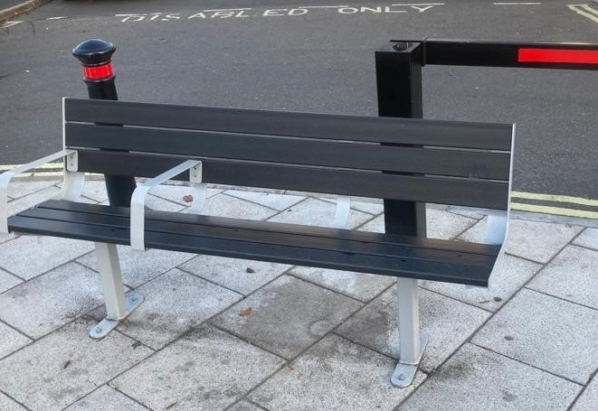

### Bench 1

#### People liked

* the look of the bench
* that it is made from recyled materials
* it was easy to identify in the environment

#### People didn’t like

* the gap beetween the back of the seat and the bottom of the backrest, they felt that their ‘bottoms were sticking out’
* the arms were too ‘sharp’ and needed to be more rounded
* the arms needed to contrast better to make them easier to see

### Bench 2

#### People liked

* the look of the bench
* that it is made from recyled materials
* the softer rounder arms
* it was easy to identify in the environment

#### People didn’t like

* the bar at the front dug into their thighs as it was slightly higher than plastic seat behind it
* some though the bar on the top at the back dug into their shoulders when sitting back

#### Preferred Bench - 2

Whereas the preferences were fairly evenly split between the two, once we brough into the conversation the cost, the Cambourne became the clear winner.

Most responders found cost as the most important factor.

We stated we could get nearly 3 Bench 2 for the price of 2 bench 1

Seat 1 = 12

Seat 2 = 30

No preference = 10

**Total responses = 52**