Business Continuity Planning

For Small to Medium Sized Businesses

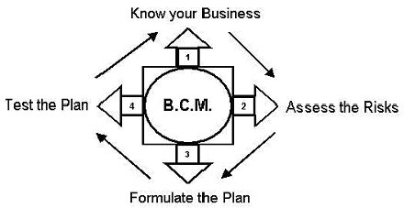Plan Template Guide

Follow the guidance below to help you complete the plan template. (the plan template can be found on page 12.)

- Know your business

- Assess the Risks

- Formulate the plan

- Test the Plan

In the plan template, complete the information on the front page and in the introduction section
Front Cover | Add your logo, company name and the date the plan was last amended
Distribution List | List who has a copy of the plan and where each copy is held. This will ensure that when you update the plan you know who will need a copy
‘Any suggested changes’ statement | Add in the name of the person who is responsible for updating the plan
References | List any other plans, legislation, policy or guidance that may be relevant to your BCP e.g. fire evacuation plan
Aim and Objectives | A generic Aim and Objective have been inserted here which can be amended if appropriate

The following guidance will help you to fill in the rest of the template……….

- KNOW YOUR BUSINESS

In order to develop a Business Continuity Plan, you need to have a thorough understanding of your business. This involves knowing the critical functions¹ being disrupted and the priority for recovery of those functions. This process is known as a ‘Business Impact Analysis’

To complete a Business Impact Analysis for each critical function, follow the guidance below:

Critical Functions:
You need to consider what the critical functions / activities are for your business- without which it would cease to operate?

Examples of Critical Functions, using a small manufacturing company as an example are:
- Staff wages
- Call centre
- IT department
- Sales
- Goods in
- Distribution
- Manufacture

NB- you will need to complete a Business Impact Analysis for each of your critical functions/teams. The plan template has 2 blank Business impact analysis tables in it. For additional Critical Functions for your business you will need to ‘copy and paste’ the table into the plan again.

^{1.}”Critical Function” is a term used to describe a function of your business without which, your
business cannot perform. The criticality of a function may change with time, e.g. performing the
role of examination moderator in a school would be more critical just before exam time than after it.

Effect on Service:
You should consider the importance of the function upon the survival of your business (percentage of income or work load, how critical the function is to other functions, etc) and how quickly each function must be re-established.

For each of the time spans detailed, identify what the effect of the loss of the critical function would be (see Illustration below)

For example, disruption to the Goods-In function could have the following effect on the business:

First 24 hours
- Lack of stock causing orders not to be completed on time
- Storage space for part processed goods, causing concern
24-48 hrs
- Manufacturing hours cut due to lack of stock
- Company reputation damaged

Up to one week
- Financial implications of missed deadlines
- Need to outsource work to maintain market share

Up to 2 weeks
- Loss of customers to competitors
- Temporary or permanent reduction in staff numbers

Resources required for recovery:
This section will help you identify what resources you need and when you need them. When completing this section you need to consider the effects of loss of function/service, per time span, as detailed in the illustration

Number of Staff:
You will probably not need all your staff to be present immediately after an emergency.

For each time span, detail how many staff you would need.

For example, if you had a problem with a key supplier and no stock was available, you may not need your fork lift truck driver, stock controllers, and quality checkers etc to be all working to full capacity within the first 24 hours.

Relocation:
Could the function be carried out by your staff anywhere else?

For example, working from home, in another branch office, mutual aid with another organisation etc.

Equipment Required:
For each time span, list what resources are required e.g.
- Computers (hardware and software)
- Vehicles
- Machinery
- Communication equipment (landlines/mobiles)

Data required

List what data is essential to the delivery of the service/ critical function eg:
- Customer contact details
- Supplier contact details
- Service/maintenance contracts and contract numbers
- Insurance details
- Costing
- Work in progress
- The completed Business Impact Analysis will assist you to prioritise what function or service you need to reinstate first during an emergency.

Using your Business Impact Analyses, complete the Critical Function Priority List in the plan template.

2. Assess the Risks

Risk is a statement of the chance of something happening that will impact on your business objective. Risk is normally considered in terms of impact and likelihood of a hazard affecting your business. By assessing your risks, you will be able to prioritise your risk reduction activities

There are many hazards that may disrupt your business these may include:

- Flooding
- It failure/loss of data/loss of key documentation
- Utility failure (water, electricity, gas, telephone)
- Fire or explosion
- Transport accident
- Extreme weather (wind, rain, snow, ice, heat)
- Loss of premises (temporary or permanent?)
- Staffing issues

These hazards will affect different businesses differently, and the critical functions within them, to varying degrees.

In the hazard analysis table list the hazards to your business, the impact of each hazard, any mitigation in place or possible and the risk matrix score.

Hazard: | In this column, list the hazards faced by your organisation.
Hazard Impact | List the physical disruption that may be caused  List the financial implications of this disruption  List people affected by the disruption (staff, clients, partners) e.g flooding event  - Loss of access and utilities  - Water damage to equipment and stock  - Cost of damage and or fines for pollution teams working on ground floor  - Customers and suppliers
Mitigation in place | List what you currently do that prevents or reduces the likelihood or the impact of the hazard. E.g. flooding event:  - Relocate premises to higher ground  - Floodgates/sandbags stored ready for use  - What could you do that you don’t do now that would reduce the risk of such an incident?
Risk matrix score: | As described below

The risk matrix, shown below, helps you to identify the higher priority risks for your business. When considering the score, you should think about any mitigation currently in place or possible

By determining the likelihood of the hazard occurring (either high or low), then determining the impact that hazards has on your business, it is possible to rate the risk as A, B, C or D.
For example:

The likelihood of a chemical spill at your business: LOW (B or D)
The Impact a chemical spill would have on your business: HIGH (A or B)
The risk matrix score would be B

When completed, the Hazard Analysis table shows which the highest risks to your business are. You can now make an informed decision as to whether to accept or treat the risk.

ACCEPT: you may decide that you are happy to ‘live with’ the risk as the cost of implementing any risk strategies may outweigh the benefits.

TREAT: you want to treat the risk i.e. take steps to reduce the impact or reduce the likelihood (possible mitigation) because the risk is too high for your business to accept.

It is not possible to mitigate against all risks, this is why a plan is required.
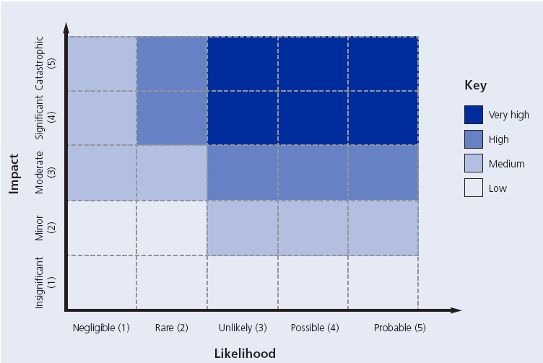

- FORMULATE THE PLAN TO RESPOND TO AN EMERGENCY

Having completed the Business Impact Analysis and Hazard analysis table, you now need to develop a generic checklist of actions that may be appropriate when an emergency occurs. The checklist in the plan template is designed for you to adapt to suit your business. You may wish to add text into the plan to outline any arrangements you already have in place, including any specific actions you would take for specific hazards.

The checklist can be used during an emergency to ensure that no major tasks are forgotten.

Start a log of actions taken | It is essential to keep a log of the actions you have taken and the decisions you have made.  Include a time with each entry.  This information will be vital if you have to defend in court any actions you have taken.  A blank copy of a log sheet is located at the end of the plan template for use during an emergency.
Liaise with Emergency Services | If the Emergency Services are involved in the incident, you will need to appoint somebody from your organisation to act as a liaison officer. This person needs to pass information between the Emergency Services and your internal response team.
Identify any damage | As soon as possible, but only if safe to do so, an assessment must be made as to the extent of what damage has been caused by the emergency.  Consider and document the following:  - Injury to staff, contractors or the public  - Damage to buildings  - Damage to equipment/vehicles  - Damage to stock  - Damage to reputation
Identify Functions Disrupted | Document which functions or areas have been disrupted and the extent of the disruption.
Convene your Business Recovery Team | You need to pre-identify who, within your organisation will make up the team that will manage the response and recovery from the emergency.  If the emergency is such that you need to call the team together, you will need to do so as soon as possible  In the contact sheet at the back of the Plan Template, identify and list the members of your response and recovery team
Provide information to staff | It is essential to keep your staff informed regarding the emergency, and the response actions being taken.  Staff may be concerned about:  - Colleagues who may be injured  - What is expected of them today  - Should they turn up for work tomorrow  - Will there still be a job for them if the building has gone up in smoke etc  Issue a number for staff to call in on or, depending on the scale and the type of the emergency, tannoy announcement, e-mail and intranet, poster in a reception area, local radio or phone call to all staff.  Remember- providing information quickly will stop rumours!
Decide on course of action | Decide what you need to do and produce an action plan. Use the Critical Function Priority List and the Business Impact analysis to assist you
Communicate decision to staff and business partners | Let staff and business partners know what you have decided to do
Provide public information to maintain reputation and business | Appoint a member of staff to act as your media representative. This person should be trained in media response techniques and be able to answer questions regarding the emergency and the business in general.  Your media representative should work in collaboration with the Emergency Services Media Officer if possible  A holding statement could be pre-prepared for your business so that you just have to fill in the blanks at the time.
Arrange a de-brief | After every emergency it is important to hold a de-brief so that you can learn from the experience.  Disseminate the lessons learnt to all concerned
Review Business Continuity Plan | Following an emergency, you should review and amend your plan as necessary

The next page of the plan template has a Key contacts list

The list should be adapted to be relevant for your business. Consider including details of key employees, utilities, insurance company, suppliers, customers, key holder, security company, partner organisations members of your response team etc.

In line with the Data Protection Act, you will need to ensure that you have the permission to hold personal information such as home contact numbers of your staff.

The final page of the plan template is a sample “Log Sheet” for you to use during an emergency.

- TEST THE PLAN
It is important that, once your plan is written, you test the procedures you have put in place.

Before a plan can be tested, employers and employees need to be familiar with the content of the plan and their role in the response and recovery. This can be done by reading through the plan together and discussing how you would apply it to a fictional scenario.

When you are confident that your members of staff understand the plan, and their part within it, you should test the plan by acting out a scenario.

The Business Continuity Management Process is an ongoing one; it is vital that the planning process does not end once the plan has been written. The plan, BIA, and risk matrix should be reviewed and tested regularly to ensure that they remain up to date and effective.

[Insert name of company/ logo]

Business Continuity Plan

Date: ____________________

Introduction

Aims of this Plan
To prepare the business to cope with the effects of an emergency

Objectives
- To define and prioritise the Critical Functions of the business
- To analyse the risks and threats to the business
- To detail the agreed response to an emergency
- To identify Key Contacts during an emergency

Distribution List
Copy Number | Name | Location
001
002
003
004
005
006

Vital references and related documents
Document Name | Location

Business Impact Analysis

Critical Function:

Effect on Service:
TIME | Effect on Service:
First 24 hours

24-48 Hours

Up to 1 week

Up to 2 weeks

Resource Requirements for Recovery:
Time | No. Staff | Relocation Y/N & location | Resources Required | Data required
First 24 hours
24-48 hours
Up to 1 week
Up to 2 weeks

Business Impact Analysis

Critical Function:

Effect on Service:
TIME | Effect on Service:
First 24 hours

24-48 Hours

Up to 1 week

Up to 2 weeks

Resource Requirements for Recovery:
Time | No. Staff | Relocation? | Resources Required | Data required
First 24 hours
24-48 hours
Up to 1 week
Up to 2 weeks

Business Impact Analysis

Critical Function:

Effect on Service:
TIME | Effect on Service:
First 24 hours

24-48 Hours

Up to 1 week

Up to 2 weeks

Resource Requirements for Recovery:
Time | No. Staff | Relocation? | Resources Required | Data required
First 24 hours
24-48 hours
Up to 1 week
Up to 2 weeks

Critical Function Priority List

Priority | Critical Function
1
2
3
4
5
6
7
8
9
10

This list can be used during an emergency to assist your decision making when compiling an Action Plan as to which functions need to be re-instated first.

Hazard Analysis Table

Risk Matrix Score
A = HIGH Likelihood and HIGH Impact
B = LOW Likelihood and HIGH Impact
C = HIGH Likelihood and LOW Impact
D = LOW Likelihood and LOW Impact

Hazard | Impact | Mitigation in Place | Mitigation Possible | Risk Matrix Score
Flooding

IT failure
Loss of Electricity
Fire
Loss of staff
Loss of key information

Emergency Response Checklist

For use during an emergency

- Start a log of actions taken

- Liaise with Emergency Services

- Identify any Damage

- Identify functions disrupted

- Convene your Response/Recovery Team

- Provide information for staff

- Decide on course of action

- Communicate decisions to staff and business partner

- Provide public information to maintain reputation and business

- Arrange a de-brief

- Review Business Continuity plan

Key Contact Sheet

Contact | Office Number | Mobile Number | Useful Information

Date | Time | Information/Decisions/Actions | Initials

